In a little-heralded but important development, luaotfload, the font loader for LuaTeX, has gained support for variable fonts. This support has been under development for years, but with the release of version 3.23, included with TeXLive 2023, support has matured: if the program has any shortcomings or bugs, I have been unable to discover them, though I have been using it almost daily for the better part of a year.
What is a variable font, then, and why should you care? A traditional (or “static”) font consists of a collection of glyphs that can can be scaled, but do not otherwise change: their proportions and such details as stem width (as a percentage of the glyph’s size) do not change. In a variable font, on the other hand, the glyphs change in one or more ways in addition to their being scalable: in Junicode, the academically oriented font I have been developing since the mid-nineties, the weight of glyphs can change, and so can their width.
Weight and width are known in the font world as “axes”—that is, aspects of a font’s design that change in a systematic way. Almost every font family has a weight axis, with “Regular” and “Bold” weights positioned at opposite ends. Extended families usually have more entries along the weight axis. The static version of Junicode has five—Light, Regular, Medium, Semibold, and Bold (fig. 1)—and many families have even more.
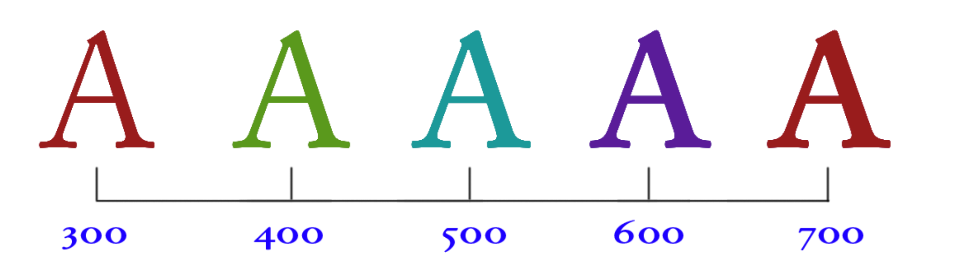A static family must consist of at least one file for each position on an axis; where there is more than one axis (Junicode’s width axis (fig. 2), for example), there may be many files—Condensed Medium, for example, or SemiExpanded Bold. One for as many styles as the font family defines, and then double that number, because Roman→Italic is also an axis, though in a Roman font like Junicode, one with only two possible positions.
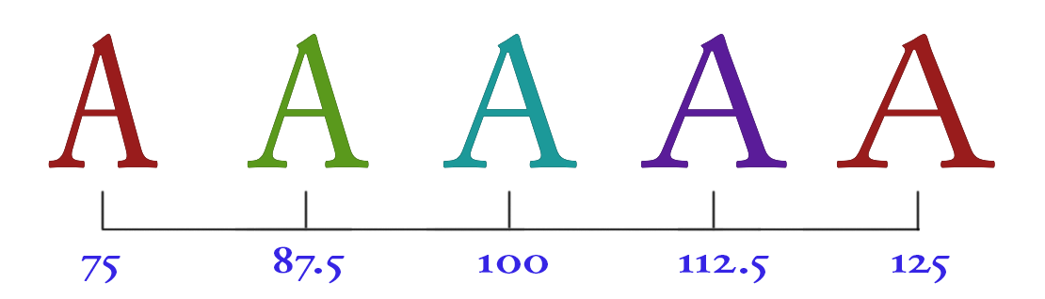
In a variable font, all the styles are packaged into one or two files: Junicode VF has one for roman and one for italic. Further, instead of a limited collection of styles occurring at intervals along the axes, the outlines in a variable font are continuously variable (fig. 3), so that the number of styles in a single font file is, for practical purposes, infinite.
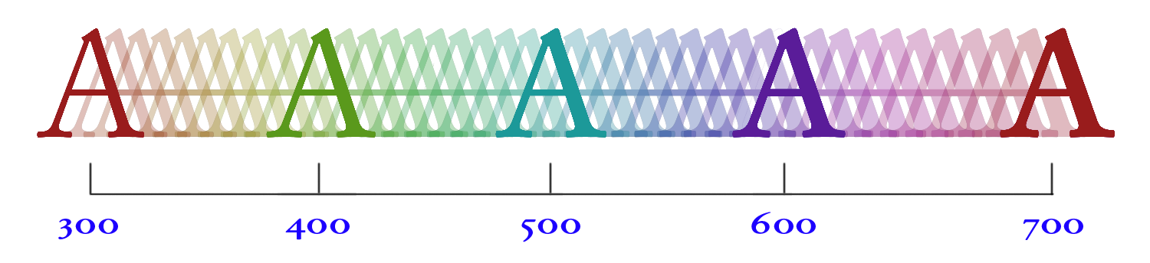
There is debate among designers and typographers about what variable fonts are good for, if anything. Websites that demonstrate these fonts—for example, https://www.axis-praxis.org/—emphasize their more spectacular aspects: how they can be animated, for example, or the spectacular stylistic effect they often achieve.

